Name: Chika Lilian Onyagu

Course Path: Data Analysis

Admin ID: DG/C23/11348

1. Which Region raked in the most Revenue?

The region with most revenue generated is Europe as shown below

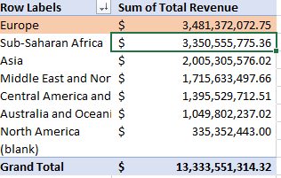

1. Who are the top five and bottom five Countries, based on profit?
2. **Top five countries based on profit**

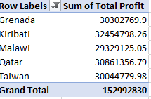

1. **bottom five countries based on profit**

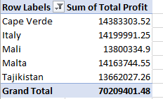

1. Display a line Chart of the Revenue by Region across the years, what was the difference between the highest and lowest Regions.

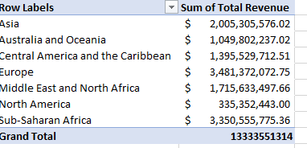

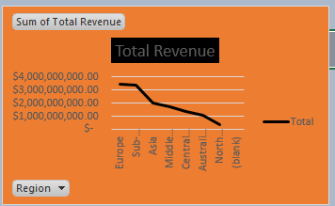

**Difference between highest region and lowest region**

$ 3,350,555,775.36 - $335,352,443.00 = $**3,015,203.33**

**4.** Compare the total cost of Baby Food items purchased by Africans and

Europeans.

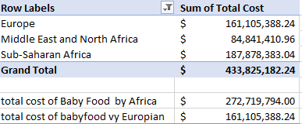

**Baby food bought by Europe is $161,105,388.24 while that of Africa is $272,719,794.00**

5. How many units of office supplies was sold to the Czech Republic?

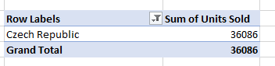

Czech Republic sold 36,086 units of items.

6. Which Country brought in the most Revenue between 2011 -2015?



**Taiwan** brought in the most Revenue between 2011 -2015

7. Which Region was the most profitable in 2015?

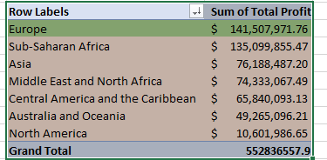

**8. Which Country ordered the most item and what item did they order the most?**

Taiwan has highest number of order with 380,647 units

With Beverages having 58,125

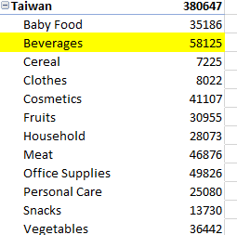

9. Which Region, and in turn Country was the least profitable through the Online

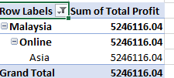

The reason for the least profit of this country could be less online presence.

10. From which Asian Country did we get the most Profit in the Beverages item

type?

**Ans: Taiwan with Beverages Profit=910237.5**

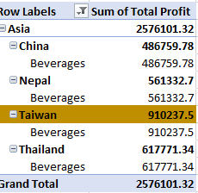

11. Compare the units of Fruits sold to Nigeria to the units of Snacks sold.

In Nigeria, Number of Fruits sold=**14,884 while snacks sold: 20,460**

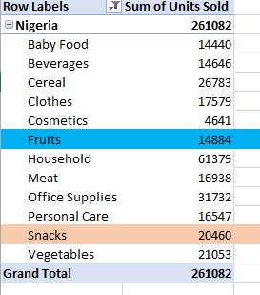

12. Looking at the data, what can you advise the Management to do to increase patronage from the bottom five Countries?

The five bottom countries are:

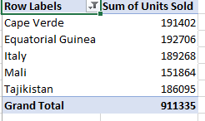

My advice to the management to these countries listed above is to give them promo prices in all their products to attract them to buy more and also offer more free website especially the countries in Sub-Sahara Africa to increase their online sales.